第五章多變數可微分函數之最適值

5.1偏導數（Partial Derivatives）
1.定義
若變數y為n個獨立變數$\left(x_{1},x_{2},\text{.}\text{.}\text{.}\text{.}\text{.}\text{.},x_{n}\right)$之函數$y=f\left(x_{1},x_{2},\text{.}\text{.}\text{.}\text{.}\text{.}\text{.},x_{n}\right)$
假設n個獨立變數之間沒有任何函數關係
今欲探討某一獨立變數x_{i}之微量改變，對應變數y之影響，則以y對x_{i}之偏導數表之：
$$\begin{aligned}\frac{∂y}{∂x_{i}}=f_{i}\left(x_{1},x_{2},\text{.}\text{.}\text{.}\text{.}\text{.}\text{.}\text{.}\text{.}\text{.}x_{n}\right) \\ =\underset{{Δx}_{i}→0}{\text{lim}}\frac{f\left(x_{1},x_{2},\text{.}\text{.}\text{.}\text{.},x_{i}+{Δx}_{i},\text{.}\text{.}\text{.}\text{.}\text{.},x_{n}\right)−f\left(x_{1},x_{2},\text{.}\text{.}\text{.}\text{.}\text{.}\text{.}\text{.}x_{i}\text{.}\text{.}\text{.}\text{.}\text{.}\text{.},x_{n}\right)}{\left(x_{i}+{Δx}_{i}\right)−x_{i}}\end{aligned}$$
例 $y=f\left(x_{1},x_{2}\right)=3x_{1}^{2}+x_{1}x_{2}+4x_{2}^{2}$
$\frac{∂y}{∂x_{1}}=f_{1}=6x_{1}+x_{2};\frac{∂y}{∂x_{2}}=f_{2}=x_{1}+8x_{2}$仍為獨立變數x₁,x₂之函數
2.偏導數仍表斜率：
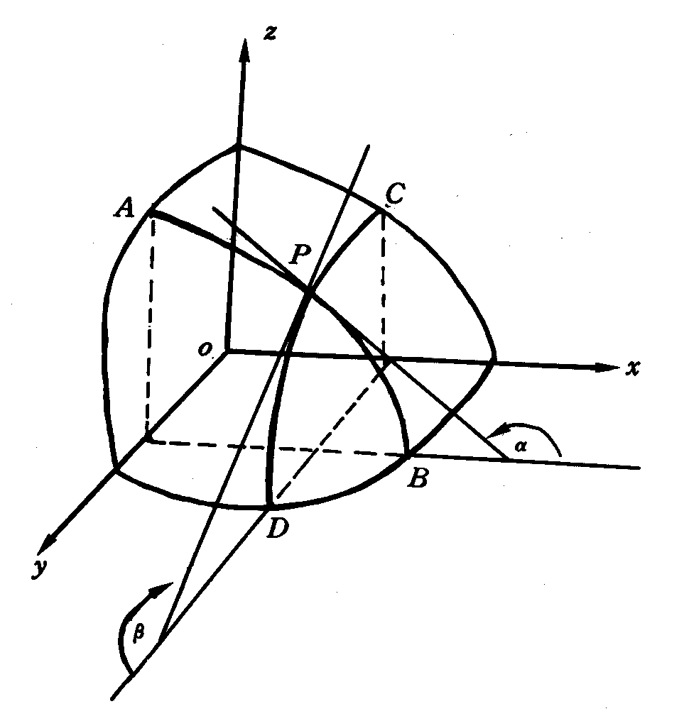
※以生產函數Q=f(L,K)為例，如下圖：
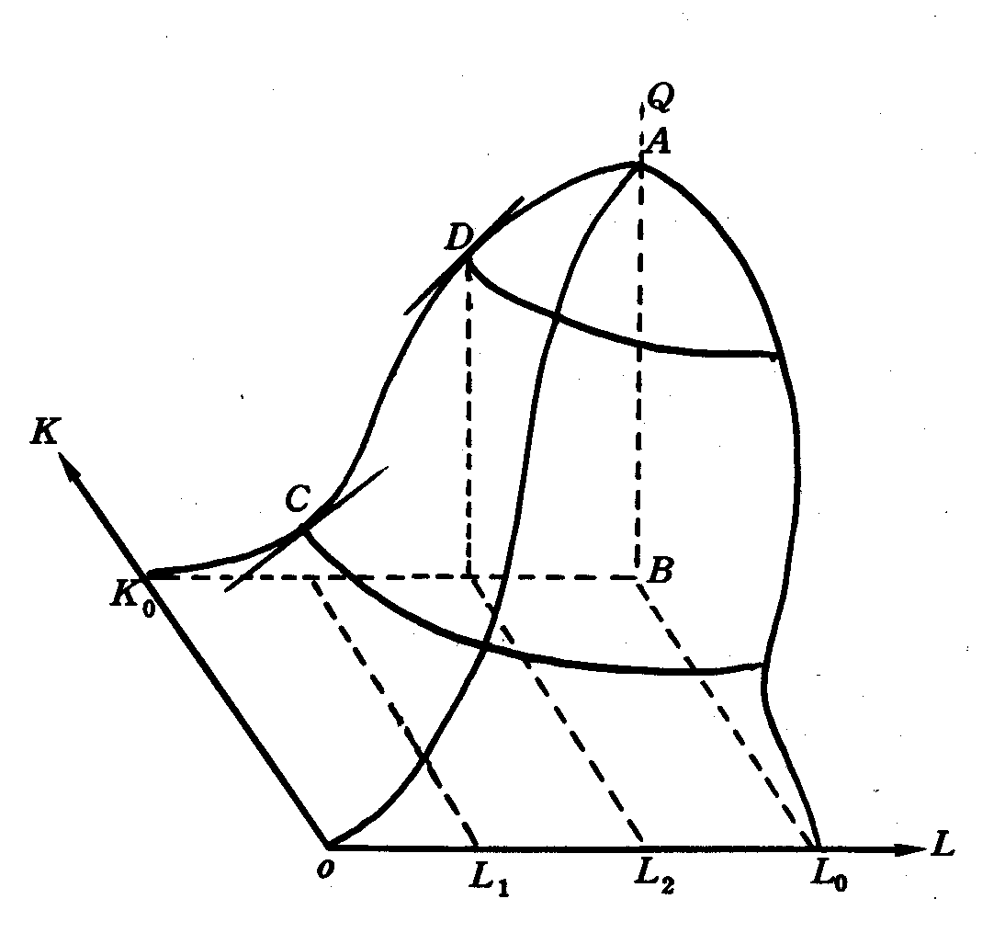
3.結論：$Z=f\left(x_{1},x_{2}\right)$有極值存在之必要條件為：$\frac{∂f\left(x_{1},x_{2}\right)}{∂x_{1}}=\frac{∂f\left(x_{1},x_{2}\right)}{∂x_{2}}=0$
可推展至n度空間。
5.2偏導數之應用
1.比較靜態分析
指經濟模型內，當外生變數或參數改變時，致使內生變數之均衡解值亦隨之改變，僅就新舊均衡解值加以比較分析，而不涉及中間之變化過程。（若涉及中間之變化過程則為動態分析）
例(1)市場模型
$$\begin{aligned}\left\{Q_{d}=a−\text{bp} \text{需求曲線} \left(a⋅b>0\right) | \right.\left\{Q_{s}=−c+\text{dp} \text{供給曲線}\left(c⋅d>0\right) | \right.\end{aligned}$$
內生變數：Qd．Qs與P
參數變數：a．b．c．d
均衡解值：$\begin{aligned}\left\{\overline{P}=\frac{a+c}{b+d}\text{.}\text{.}\text{.}\text{.}\text{.}\text{.}\text{.}\text{.}\text{.}\text{.}\text{.}\text{.}\text{.}\text{.}\text{.}\text{.}\text{.}\text{.}\text{.}\text{.}\text{.}\text{.}\text{.}\text{.}\text{.}\text{.}\text{.}\text{.}\text{.}\text{.}\text{.}\text{.}\text{.}\text{.}\text{.}\text{.}\text{.}\left(5−2\right) | \right.\end{aligned}$
今欲探討某一參數（如a）之微量改變，如何影響到內生變數（如p）之均衡解值（$\overline{P}$）？
只須就式（5-2）中$\overline{P}$對a求其偏導數：$\frac{∂\overline{P}}{∂a}$
※$\frac{∂\overline{Q}}{∂a}$與$\frac{∂\text{Qd}}{∂a}$之不同：
$\frac{∂\text{Qd}}{∂a}$單指對需求曲線之影響，未涉及到對供給曲線之影響。
而若將內生變數之均衡解值（$\overline{P}$或$\overline{Q}$）對有關參數之偏導數，稱為比較靜態導數，則涉及供需曲線之同時交互作用。依式（5-2）、（5-3）共有八個偏導數：
$$\begin{aligned}\frac{∂\overline{P}}{∂a}=\frac{1}{b+d}>0;\frac{∂\overline{P}}{∂b}=−\frac{a+c}{{\left(b+d\right)}^{2}}<0;\frac{∂\overline{P}}{∂c}=\frac{1}{\left(b+d\right)}>0; \\ \frac{∂\overline{P}}{∂d}=−\frac{a+c}{{\left(b+d\right)}^{2}}<0 \\ \frac{∂\overline{Q}}{∂a}=\frac{d}{b+d}>0;\frac{∂\overline{Q}}{∂b}=\frac{−d\left(a+c\right)}{{\left(b+d\right)}^{2}}<0;\frac{∂\overline{Q}}{∂c}=−\frac{b}{\left(b+d\right)}<0 \\ \frac{∂\overline{Q}}{∂d}=\frac{b\left(a+c\right)}{{\left(b+d\right)}^{2}}>0\end{aligned}$$
例(2)封閉性經濟體系國民所得之均衡模式（Y、C、T為內生變數）
$$\begin{aligned}\begin{aligned}\left\{Y=C+\text{Io}+\text{Go} | \right.\left\{C=\text{Co}+α\left(Y−T\right), 0<α=\text{MPC}<1 | \right.\end{aligned} \\ \end{aligned}$$
求解式（5-5）之方法有2種方法：行列式法、反矩陣法
$$\begin{aligned}\overline{Y}=\frac{1}{1−\left(1−t\right)α}\left(\text{Co}+\text{Io}+\text{Go}−α\text{To}\right)\text{.}\text{.}\text{.}\text{.}\text{.}\text{.}\text{.}\text{.}\text{.}\text{.}\text{.}\text{.}\text{.}\text{.}\text{.}\text{.}\text{.}\text{.}\text{.}\text{.}\text{.}\text{.}\text{.}\text{.}\left(5−6\right) \\ \overline{C}=\frac{1}{1−\left(1−t\right)α}\left[\text{Co}+\left(1−t\right)α\left(\text{Io}+\text{Go}\right)−α\text{To}\right] \\ \overline{T}=\frac{1}{1−\left(1−t\right)α}\left[t\left(\text{Co}+\text{Io}+\text{Go}\right)+\left(1−α\right)\text{To}\right]\end{aligned}$$
欲探討任一外生變數或參數的改變，對均衡國民所得$\overline{Y}$的影響，就式（5-6）求偏導數：
自發性消費支出乘數：$\frac{∂\overline{Y}}{∂\text{Co}}=\frac{1}{1−\left(1−t\right)α}>0$
自發性投資支出乘數：$\frac{∂\overline{Y}}{∂\text{Io}}=\frac{1}{1−\left(1−t\right)α}>0$
自發性政府支出乘數：$\frac{∂\overline{Y}}{∂\text{Go}}=\frac{1}{1−\left(1−t\right)α}>0$
自發性政府租稅乘數：$\frac{∂\overline{Y}}{∂\text{To}}=\frac{−α}{1−\left(1−t\right)α}<0$
稅率乘數：$\frac{∂\overline{Y}}{∂t}=−\frac{α\left(\text{Co}+\text{Io}+\text{Go}−α\text{To}\right)}{{\left[1−\left(1−t\right)α\right]}^{2}}<0$
邊際消費傾向乘數：$\frac{∂\overline{Y}}{∂α}=\frac{\left(1−t\right)\left(\text{Co}+\text{Io}+\text{Go}\right)−\text{To}}{{\left[1−\left(1−t\right)α\right]}^{2}}$
2.判別函數是否相依（Jacobian行列式）
- 用途：利用偏導數檢定由n個變數與n個函數所構成之聯立方程式，其各函數之間是否彼此獨立或相依（線性或非線性）
- 實例：
$$\begin{aligned}\left\{y_{1}\left(x_{1},x_{2}\right)=x_{1}+x_{2} | \right.\end{aligned}$$

⇒偏導數如右：$\begin{aligned}\left\{\frac{∂y_{1}}{∂x_{1}}=1,\frac{∂y_{1}}{∂x_{2}}=1 | \right.\end{aligned}$
將上述4個偏導數構成一方陣，然後就此方陣取其行列式，則稱為Jacobian行列式或簡稱Jacobian，以⎢J⎥表示之：
$$\left|J\right|=\begin{aligned}\left|\frac{∂y_{1}}{∂x_{1}} \frac{∂y_{1}}{∂x_{2}} | \right| \\ \end{aligned}$$
兩函數兩變數所構成之聯立方程式， 將其Jacobin簡寫成$\left|J\right|=\frac{∂\left(y_{1},y_{2}\right)}{∂\left(x_{1},x_{2}\right)}$
若聯立方程式由n個可微分函數與n個變數所構成：
$$\begin{aligned}\left\{y_{1}=f^{1}\left(x_{1},x_{2},\text{.}\text{.}\text{.}\text{.}\text{.}\text{.}\text{.}\text{.}\text{.},x_{n}\right) | \right.\left\{y_{2}=f^{2}\left(x_{1},x_{2},\text{.}\text{.}\text{.}\text{.}\text{.}\text{.}\text{.}\text{.},x_{n}\right) | \right.\left\{ ⋮ ⋮ ⋮ | \right.\end{aligned}$$
因此$\left|J\right|=\frac{∂\left(y_{1},y_{2},\text{.}\text{.}\text{.}\text{.}\text{.}y_{n}\right)}{∂\left(x_{1},x_{2},\text{.}\text{.}\text{.}\text{.}\text{.}\text{.}x_{n}\right)}=\begin{aligned}\left|\frac{∂y_{1}}{∂x_{1}} \frac{∂y_{1}}{∂x_{2}}⋯⋯⋯\frac{∂y_{1}}{∂x_{n}} | \right|\left|\frac{∂y_{2}}{∂x_{1}} \frac{∂y_{2}}{∂x_{2}}⋯⋯⋯\frac{∂y_{n}}{∂x_{n}} | \right|\left| ⋮ ⋮ ⋮ | \right| \\ \end{aligned}$
判定的方法如下：
$\left|J\right|=0$，則函數相依
$\left|J\right|≠0$，則各函數間彼此獨立
3.齊次函數（Homogenous Functions）與Euler定理
(1)齊次函數：若將函數$f\left(x_{1},x_{2},\text{.}\text{.}\text{.}\text{.}\text{.}\text{.},x_{n}\right)$之所有獨立變數x_{i}乘以常數k（k>0），如使原函數值增加k^{m}倍，即
$f\left({\text{kx}}_{1},{\text{kx}}_{2},\text{.}\text{.}\text{.}\text{.}\text{.}\text{.}\text{.}\text{.},{\text{kx}}_{n}\right)=k^{m}f\left(x_{1},x_{2},\text{.}\text{.}\text{.}\text{.}\text{.}\text{.}\text{.}\text{.}x_{n}\right)$則此函數為m次齊次函數。
(2)例子：$Z=f\left(x,y\right)=x^{2}y+2y^{3}+{\text{xy}}^{2}−\text{10}x^{3}$， 令k=2則
$$\begin{aligned}f\left(2x,2y\right)={\left(2x\right)}^{2}\left(2y\right)+2{\left(2y\right)}^{3}+\left(2x\right){\left(2y\right)}^{2}−\text{10}{\left(2x\right)}^{3} \\ =2^{3}x^{2}y+2^{3}×2y^{3}+2^{3}{\text{xy}}^{2}−2^{3}×\text{10}x^{3} \\ =2^{3}\left(x^{2}y+2y^{3}+{\text{xy}}^{2}−\text{10}x^{3}\right) \\ =2^{3}f\left(x,y\right)\end{aligned}$$
∵m=3
∴此函數為三次齊次函數
(3)經濟例子：生產函數
(Ι) Q=f（K,L）為要素K與L之n次齊次函數

n=1，則為規模報酬固定（Constant Return to Scale，簡稱CRTS）之生產函數。
n>1，則為規模報酬遞增（簡稱IRTS）之生產函數。
● n<1，則為規模報酬遞減（簡稱DRTS）之生產函數。
(Π)若生產函數Q=f（k,L）呈一次齊次式，其特性有：
a.各生產要素之平均產量均為要素比之零次齊次式，即
${\text{AP}}_{L}=f\left(\frac{K}{L}\right)$與${\text{AP}}_{K}=f\left(\frac{1}{\frac{K}{L}}\right)$
証明：$Q=f\left(K,L\right)⇒λQ=f\left(λK,λL\right)$, k=$\frac{K}{L}$ (k為資本-勞動比)

令$λ=\frac{1}{L}$，則$f\left(\frac{K}{L},1\right)=\frac{Q}{L}={\text{AP}}_{L}⇒{\text{AP}}_{L}=φ\left(\frac{K}{L}\right)=φ(k)$, 其中$φ\left(\frac{K}{L}\right)=f\left(\frac{K}{L},1\right)$
同理，令$λ=\frac{1}{K}$，則$f\left(1,\frac{L}{K}\right)=\frac{Q}{K}={\text{AP}}_{K}⇒{\text{AP}}_{K}=\frac{Q}{L}×\frac{L}{K}=\frac{φ(k)}{k}$
b.各生產要素之邊際產量亦為要素比之零次齊次式
$$\begin{aligned}{\text{MP}}_{L}=\frac{∂Q}{∂L}=\frac{∂\left({\text{AP}}_{L}⋅L\right)}{∂L}=\frac{∂φ\left(\frac{K}{L}\right)⋅L}{∂L}=φ\left(\frac{K}{L}\right)+L⋅\frac{∂φ\left(\frac{K}{L}\right)}{∂L} \\ =φ\left(\frac{K}{L}\right)+L⋅\frac{∂φ\left(\frac{K}{L}\right)}{∂\left(\frac{K}{L}\right)}×\frac{∂\left(\frac{K}{L}\right)}{∂L}=φ\left(\frac{K}{L}\right)+L⋅φ'\left(\frac{K}{L}\right)⋅\frac{−K}{L^{2}} \\ =φ\left(\frac{K}{L}\right)−\frac{K}{L}⋅φ'\left(\frac{K}{L}\right)=φ(k)−k⋅φ^{'}(k)\end{aligned}$$
同理${\text{MR}}_{K}=\frac{∂Q}{∂K}=\frac{∂({\text{AP}}_{L}⋅L)}{∂K}=\frac{∂\left[φ\left(\frac{K}{L}\right)⋅L\right]}{∂K}=L⋅φ'\left(\frac{K}{L}\right)⋅\frac{1}{L}=φ'\left(\frac{K}{L}\right)=φ^{'}(k)$
Euler定理
若$Z=f\left(x_{1},x_{2},\text{.}\text{.}\text{.}\text{.}\text{.}\text{.}\text{.},\text{.}x_{n}\right)$為m次齊次式，且第一次偏導數存在，
則$\sum_{i=1}^{n}{\frac{∂Z}{∂x_{i}}}\left(x_{i}\right)=\text{mZ}$……………….
proof: $f\left({\text{kx}}_{1},{\text{kx}}_{2},\text{.}\text{.}\text{.}\text{.}\text{.}\text{.}\text{.}\text{.}{\text{kx}}_{n}\right)=k^{m}f\left(x_{1},x_{2},\text{.}\text{.}\text{.}\text{.}\text{.}\text{.},x_{n}\right)$
對k求偏導數：$\frac{∂}{∂k}\left[f\left({\text{kx}}_{1},{\text{kx}}_{2},\text{.}\text{.}\text{.}\text{.}\text{.}\text{.}\text{.}\text{.},{\text{kx}}_{n}\right)\right]=\frac{∂}{∂k}\left[k^{m}f\left(x_{1},x_{2},\text{.}\text{.}\text{.}\text{.}\text{.}\text{.}\text{.}\text{.}\text{.}x_{n}\right)\right]$
令f(•)表$f\left({\text{kx}}_{1},{\text{kx}}_{2},\text{.}\text{.}\text{.}\text{.}\text{.}\text{.}\text{.}\text{.}{\text{kx}}_{n}\right)$，則$\begin{aligned}\frac{∂}{∂{\text{kx}}_{1}}\left[f\left(\right)\right]\frac{∂}{∂k}\left({\text{kx}}_{1}\right)+\frac{∂}{∂{\text{kx}}_{2}}\left[f\left(\right)\right]\frac{∂}{∂k}\left({\text{kx}}_{2}\right)+\text{.}\text{.}\text{.}\text{.}\text{.}+\frac{∂}{∂{\text{kx}}_{n}}\left[f\left(\right)\right]\frac{∂}{∂k}\left({\text{kx}}_{n}\right)={\text{mk}}^{m−1}f\left(x_{1},x_{2},\text{.}\text{.}\text{.},x_{n}\right) \\ f_{{\text{kx}}_{1}}⋅x_{1}+f_{{\text{kx}}_{2}}x_{2}+\text{.}\text{.}\text{.}\text{.}\text{.}\text{.}\text{.}\text{.}\text{.}+f_{{\text{kx}}_{n}}x_{n}={\text{mk}}^{m−1}f\left(x_{1},x_{2},\text{.}\text{.}\text{.}\text{.}\text{.}\text{.}x_{n}\right)\end{aligned}$令k=1，則$f_{x_{1}}⋅x_{1}+f_{x_{2}}x_{2}+\text{.}\text{.}\text{.}\text{.}\text{.}\text{.}\text{.}\text{.}+f_{x_{n}}x_{n}=\text{mf}\left(x_{1},x_{2},\text{.}\text{.}\text{.}\text{.}\text{.}\text{.},x_{n}\right)$
$⇒\sum_{i=1}^{n}{\frac{∂Z}{∂x_{i}}}\left(x_{i}\right)=\text{mZ}$
例1.Euler定理適用於分配理論
齊次函數必適用Euler定理，反之若能適用Euler定理的函數，必為齊次函數。
如生產函數Q=f（K,L）為n次齊次函數，依據Euler定理
$$\text{nQ}=\frac{∂Q}{∂K}K+\frac{∂Q}{∂L}L={\text{MP}}_{K}⋅K+{\text{MP}}_{L}⋅L$$
兩邊同乘P，若產品市場與要素市場均為完全競爭
$n⋅\text{PQ}=(P⋅{\text{MP}}_{K})K+(P⋅{\text{MP}}_{L})L={\text{VMP}}_{K}⋅K+{\text{VMP}}_{L}⋅L$

VMP_{K}：為資本的邊際產值
VMP_{L}：為勞動的邊際產值
$$\begin{aligned}n⋅\text{TR}=\text{TC}⇔\text{TR}−\text{TC}=\left(1−n\right)\text{TR} \\ ⇒π=\text{TR}−\text{TC}=\left(1−n\right)\text{TR}\frac{}{}0⇒1\frac{}{}n\end{aligned}$$
n<1，規模報酬遞減，有超額利潤π>0
n=1，規模報酬固定，利潤為零π=0
n>1，規模報酬遞增，利潤為負π<0
例2. Cobb Douglas生產函數
$$Q=f\left(K,L\right)={\text{AK}}^{α}L^{β}$$
(1)$A{\left(λK\right)}^{α}{\left(λL\right)}^{β}=λ^{α+β}{\text{AK}}^{α}L^{β}=λ^{α+β}Q⇒\left(α+β\right)$ 次齊次生產函數
(2)依Euler定理
$\begin{aligned}\frac{∂Q}{∂K}K+\frac{∂Q}{∂L}L=\left(α+β\right)Q \\ {\text{MP}}_{K}⋅K+{\text{MP}}_{L}⋅L=\left(α+β\right)Q\end{aligned}$
兩邊同乘P：$\left(P⋅{\text{MP}}_{K}\right)K+\left(P⋅{\text{MP}}_{L}\right)L=\left(α+β\right)\text{PQ}$
$\begin{aligned}{\text{VMP}}_{K}⋅K+{\text{VMP}}_{L}⋅L=\left(α+β\right)\text{TR} \\ \text{TC}=\left(α+β\right)\text{TR}⇒π=\text{TR}−\text{TC}=\text{TR}\left[1−\left(α+β\right)\right]\frac{}{}0⇒α+β\frac{}{}1\end{aligned}$

5-3全微分（Total Differential）

※若多變數函數：$y=f\left(x_{1},x_{2},\text{.}\text{.}\text{.}\text{.}\text{.}\text{.},x_{n}\right)$，獨立變數$x_{1},x_{2},\text{.}\text{.}\text{.}\text{.}\text{.}\text{.},x_{n}$彼此間有函數關係，則欲探討某一獨立變數（x_{i}）對應變數y之影響，則不能用偏導數。此時全微分可彌補偏導數之不足。
※導數與微分之分別：
$$\begin{aligned}y=f\left(x\right)⇒\frac{\text{dy}}{\text{dx}}=f'\left(x\right),\text{表示兩變數微小變量之比} \\ \text{dy}=f'\left(x\right)\text{dx},\text{表示某一變數之微量變量}\end{aligned}$$
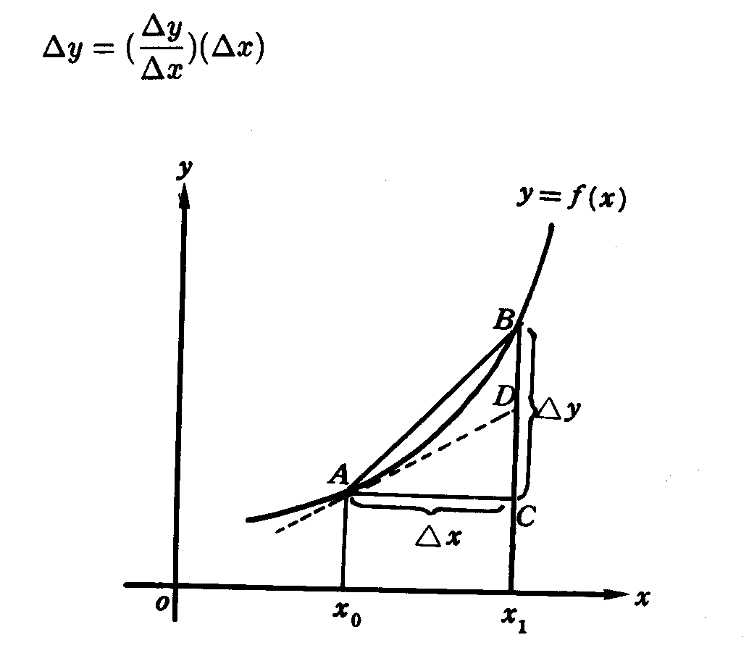
1.定義
設n變數函數f在點p為可微分，$∀h=(h_{1},h_{2},⋯,h_{n})∈R^{n}$則稱
$\text{df}\left(p,h\right)=D_{1}f\left(p\right)h_{1}+D_{2}f\left(p\right)h_{2}+\text{.}\text{.}\text{.}\text{.}\text{.}\text{.}\text{.}\text{.}\text{.}+D_{n}f\left(p\right)h_{n}$為f在點p對h之全微分
當$\left|h\right|$很小時，df（p,h）可作為f（p+h）－f（p）之近似值，古典微積分的寫法是：
二變函數：$\text{df}=\frac{∂f}{∂x}\text{dx}+\frac{∂f}{∂y}\text{dy}$
三變函數：$\text{df}=\frac{∂f}{∂x}\text{dx}+\frac{∂f}{∂y}\text{dy}+\frac{∂f}{∂z}\text{dz}$
其中dx相當於h₁，dy相當於h₂，dz相當於h₃。
2.例：效用函數
$$U=U\left(x_{1},x_{2},\text{.}\text{.}\text{.}\text{.}\text{.}\text{.},x_{n}\right)$$
上式說明效用水準受到n種商品數量所影響，全微分：
$$\begin{aligned}\text{dU}=\frac{∂U}{∂X_{1}}{\text{dx}}_{1}+\frac{∂U}{∂X_{2}}{\text{dx}}_{2}+\text{.}\text{.}\text{.}\text{.}\text{.}\text{.}\text{.}\text{.}+\frac{∂U}{∂X_{n}}{\text{dx}}_{n} \\ ={\text{MUx}}_{1}{\text{dx}}_{1}+{\text{MUx}}_{2}{\text{dx}}_{2}+\text{.}\text{.}\text{.}\text{.}\text{.}\text{.}\text{.}\text{.}\text{.}\text{.}+{\text{MUx}}_{n}{\text{dx}}_{n} \\ ⇒\text{dU}=\sum_{i=1}^{n}{{\text{MUx}}_{i}{\text{dx}}_{i}}\end{aligned}$$
即總效用之改變，等於各商品之邊際效用與各商品增量乘積之和
3.彈性
- 價格需求彈性：$ε_{\text{QP}}=\frac{\frac{∂Q}{Q}}{\frac{∂P}{P}}=\frac{∂Q}{∂P}×\frac{P}{Q}$
- 效用函數之偏彈性：$ε_{{\text{Ux}}_{i}}=\frac{∂U}{∂x_{i}}\frac{x_{i}}{U}$

5-4等函數值之曲線斜率

※經濟學實例：
1.效用函數：$U=U\left(x,y\right)$
U之全微分：$\text{dU}=\frac{∂U}{∂x}\text{dx}+\frac{∂U}{∂y}\text{dy}={\text{MU}}_{x}\text{dx}+{\text{MU}}_{y}\text{dy}$
同一條無異曲線上，效用維持不變即dU=0（效用變動量=0）
則其斜率為$m_{\overline{u}}=\frac{\text{dy}}{\text{dx}}|_{{\text{du}}_{=0}}={\text{MRS}}_{x−y}=−\frac{{\text{MU}}_{x}}{{\text{MU}}_{y}}<0$
2.長期生產函數：Q=Q（L,K）
Q之全微分：$\text{dQ}=\frac{∂Q}{∂L}\text{dL}+\frac{∂Q}{∂K}\text{dK}={\text{MP}}_{L}\text{dL}+{\text{MP}}_{K}\text{dK}$
同一條等產量曲線上，產量維持不變，即dQ=0
則其斜率為$m_{\overline{Q}}=\frac{\text{dK}}{\text{dL}}|_{\text{dQ}=0}={\text{MRTS}}_{L−K}=−\frac{{\text{MP}}_{L}}{{\text{MP}}_{K}}<0$（邊際技術替代率）
3.消費者預算線：$\overline{M}=\overline{P_{x}}⋅X+\overline{P_{y}}⋅y$
全微分得：$d\overline{M}=0=\overline{P_{x}}\text{dx}+\overline{P_{y}}\text{dy}⇒\frac{\text{dy}}{\text{dx}}=−\frac{\overline{P_{x}}}{\overline{P_{y}}}<0$
4.等成本曲線：$\overline{C}=\overline{P_{L}}⋅L+\overline{P_{K}}⋅K$
全微分得：$\overline{\text{dC}}=0=\overline{P_{L}}⋅\text{dL}+\overline{P_{K}}⋅\text{dk}⇒m_{\overline{C}}=\frac{\text{dK}}{\text{dL}}|_{d\bar{C}=0}=−\frac{\overline{P_{L}}}{\overline{P_{K}}}<0$

5-5合成函數之全導數（Total Derivatives）
1.定義
若 y=f（x,w）…………………（5-46）
x=g（w）
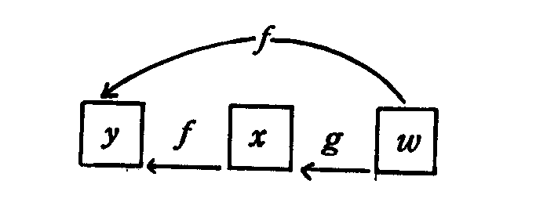
y受到x,w兩變數所影響，x又受到w之影響
y可視為w之單變數函數，此三變數之關係如上圖。
欲求y對w之全導數，首先得對式（5-46）求全微分
$$\begin{aligned}\begin{aligned}\left\{\text{dy}=\text{fxdx}+\text{fwdw} | \right.\end{aligned} \\ \end{aligned}$$

(1) (2)
式（5-47）中：
(1)為w直接影響x，而後x再影響到y，即w間接影響到y
(2)為w對y之直接影響
範例： $\begin{aligned}y=f\left(x,w\right)=3x−w^{2} \\ x=g\left(w\right)=2w^{2}+w+4\end{aligned}$ 則$\frac{\text{dy}}{\text{dw}}=3\left(4w+1\right)+\left(−2w\right)=\text{10}w+3$
2.經濟實例：生產函數Q=Q（K,L）且K=K（t）與L=L（t），t為時間。欲探討時間t之微量改變對產量之影響，則Q得對t求導數：
$$\frac{\text{dQ}}{\text{dt}}=\frac{∂Q}{∂K}\frac{\text{dK}}{\text{dt}}+\frac{∂Q}{∂L}\frac{\text{dL}}{\text{dt}}$$
再同除Q: $\begin{aligned}\frac{\frac{\text{dQ}}{\text{dt}}}{Q}=\frac{K⋅\frac{∂Q}{∂K}}{Q}\frac{\frac{\text{dK}}{\text{dt}}}{K}+\frac{L⋅\frac{∂Q}{∂L}}{Q}\frac{\frac{\text{dL}}{\text{dt}}}{L} \\ ⇒G_{Q}=E_{Q−K}⋅G_{K}+E_{Q−L}⋅G_{L}\end{aligned}$
產量成長率等於各要素偏產出彈性與各要素成長率乘積之和

5-6隱函數之導數（implicitfunction）
1.定義
已知F（x,y）=0為x與y之隠函數，求$\frac{\text{dy}}{\text{dx}}$時僅需將y視為x之未知函數，然後F對X求其微分。
2.實例：
例1：$x^{3}−2x^{2}y^{2}+y^{4}−5=0,$求$\frac{\text{dy}}{\text{dx}}$=？
$\begin{aligned}\frac{d}{\text{dx}}\left(x^{3}\right)−\frac{d}{\text{dx}}\left(2x^{2}y^{2}\right)+\frac{d}{\text{dx}}\left(y^{4}\right)−\frac{d}{\text{dx}}\left(5\right)=0 \\ 3x^{2}−4{\text{xy}}^{2}−4x^{2}y\frac{\text{dy}}{\text{dx}}+4y^{3}\frac{\text{dy}}{\text{dx}}=0 \\ ⇒\frac{\text{dy}}{\text{dx}}=\frac{4{\text{xy}}^{2}−3x^{2}}{4\left(y^{3}−x^{2}y\right)},\left(y^{3}−x^{2}y≠0\right)\end{aligned}$
3.隠函數之聯立方程式
隠函數$\begin{aligned}\left\{F^{1}\left(y_{1},y_{2},\text{.}\text{.}\text{.}\text{.}\text{.}\text{.},y_{n};x_{1},x_{2},\text{.}\text{.}\text{.}\text{.}\text{.}\text{.},x_{n}\right)=0 | \right.\left\{F^{2}\left(y_{1},y_{2},\text{.}\text{.}\text{.}\text{.}\text{.}\text{.},y_{n};x_{1},x_{2},\text{.}\text{.}\text{.}\text{.}\text{.}\text{.},x_{n}\right)=0 | \right.\left\{ ⋮ ⋮ ⋮ | \right.\end{aligned}$……….（5-49）
上式中，y_{i}表內生變數，x_{j}表外生變數
可進一步將所有之內生變數y_{i}均以外生變數x_{j}表之，所構成之聯立方程式，稱為y_{i}之縮簡式。
顯函數$\begin{aligned}\left\{y_{1}=f^{1}\left(x_{1},x_{2},\text{.}\text{.}\text{.}\text{.}\text{.}\text{.},x_{n}\right) | \right.\left\{y_{2}=f^{2}\left(x_{1},x_{2},\text{.}\text{.}\text{.}\text{.}\text{.}\text{.},x_{n}\right) | \right.\left\{ ⋮ ⋮ | \right.\end{aligned}$……….（5-50）
法一：
首先對式（5-49）求全微分將內生變數dy_{i}與外生變數dx_{j}之項分別以等號分開。
$\begin{aligned}\left\{\frac{∂F^{1}}{∂y_{1}}{\text{dy}}_{1}+\frac{∂F^{1}}{∂y_{2}}{\text{dy}}_{2}+\text{.}\text{.}\text{.}\text{.}\text{.}\text{.}+\frac{∂F^{1}}{∂y_{n}}{\text{dy}}_{n}=−\left(\frac{∂F^{1}}{∂x_{1}}{\text{dx}}_{1}+\frac{∂F^{1}}{∂x_{2}}{\text{dx}}_{2}+\text{.}\text{.}\text{.}\text{.}+\frac{∂F^{1}}{∂x_{m}}{\text{dx}}_{m}\right) | \right.\left\{\frac{∂F^{2}}{∂y_{1}}{\text{dy}}_{1}+\frac{∂F^{2}}{∂y_{2}}{\text{dy}}_{2}+\text{.}\text{.}\text{.}\text{.}\text{.}\text{.}+\frac{∂F^{2}}{∂y_{n}}{\text{dy}}_{n}=−\left(\frac{∂F^{2}}{∂x_{1}}{\text{dx}}_{1}+\frac{∂F^{2}}{∂x_{2}}{\text{dx}}_{2}+\text{.}\text{.}\text{.}\text{.}+\frac{∂F^{2}}{∂x_{m}}{\text{dx}}_{m}\right) | \right.\left\{ ⋮ ⋮ | \right.\end{aligned}$…（5-51）
如欲分析某一外生變數（x₁）之微量改變，對所有內生變數（y_{i}）之影響。首先將其他外生變數$\left(x_{2},x_{3},\text{.}\text{.}\text{.}\text{.}\text{.}\text{.},x_{m}\right)$視為不變$\left(即{\text{dx}}_{2}={\text{dx}}_{3}=\text{.}\text{.}\text{.}\text{.}\text{.}\text{.}={\text{dx}}_{m}=0\right)$，然後以dx₁遍除（5-51），得各內生變數對之x₁偏導數：
$\begin{aligned}\left\{\left(\frac{∂F^{1}}{∂y_{1}}\right)\left(\frac{∂y_{1}}{∂x_{1}}\right)+\left(\frac{∂F^{1}}{∂y_{2}}\right)\left(\frac{∂y_{2}}{∂x_{1}}\right)+\text{.}\text{.}\text{.}\text{.}\text{.}\text{.}+\left(\frac{∂F^{1}}{∂y_{n}}\right)\left(\frac{∂y_{n}}{∂x_{1}}\right)=−\frac{∂F^{1}}{∂x_{1}} | \right.\left\{\left(\frac{∂F^{2}}{∂y_{1}}\right)\left(\frac{∂y_{1}}{∂x_{1}}\right)+\left(\frac{∂F^{2}}{∂y_{2}}\right)\left(\frac{∂y_{2}}{∂x_{1}}\right)+\text{.}\text{.}\text{.}\text{.}\text{.}\text{.}+\left(\frac{∂F^{2}}{∂y_{n}}\right)\left(\frac{∂y_{n}}{∂x_{1}}\right)=−\frac{∂F^{2}}{∂x_{1}} | \right.\left\{ ⋮ ⋮ ⋮ | \right.\end{aligned}$……（5-52）
將（5-52）以矩陣列出
係數矩陣 變數矩陣 常數矩陣
$$\begin{aligned}\left[\frac{∂F^{1}}{∂y_{1}} \frac{∂F^{1}}{∂y_{2}}\text{.}\text{.}\text{.}\text{.}\text{.}\text{.}\text{.}\text{.}\text{.}\text{.}\frac{∂F^{1}}{∂y_{n}} | \right]\left[\frac{∂F^{2}}{∂y_{1}} \frac{∂F^{2}}{∂y_{2}}\text{.}\text{.}\text{.}\text{.}\text{.}\text{.}\text{.}\text{.}\text{.}\text{.}\frac{∂F^{2}}{∂y_{n}} | \right]\left[ ⋮ ⋮ | \right] \\ \end{aligned}$$
令$\left|J\right|=\left|\frac{∂\left(F^{1},F^{2},\text{.}\text{.}\text{.}\text{.}\text{.}\text{.},F^{n}\right)}{∂\left(y_{1},y_{2},\text{.}\text{.}\text{.}\text{.}\text{.}\text{.}\text{.}\text{.}\text{.}y_{n}\right)}\right|=\begin{aligned}\left|\frac{∂F^{1}}{∂y_{1}} \frac{∂F^{1}}{∂y_{2}}\text{.}\text{.}\text{.}\text{.}\text{.}\text{.}\text{.}\text{.}\text{.}\text{.}\text{.}\text{.}\text{.}\text{.}\text{.}\frac{∂F^{1}}{∂y_{n}} | \right|\left|\frac{∂F^{2}}{∂y_{1}} \frac{∂F^{2}}{∂y_{2}}\text{.}\text{.}\text{.}\text{.}\text{.}\text{.}\text{.}\text{.}\text{.}\text{.}\text{.}\text{.}\text{.}\text{.}\text{.}\frac{∂F^{2}}{∂y_{n}} | \right|\left| ⋮ ⋮ | \right| \\ \end{aligned}$ 才有解
利用Cramer’s Rule：
$\frac{∂y_{1}}{∂x_{1}}=\frac{1}{\left|J\right|} \begin{aligned}\left|−\frac{∂F^{1}}{∂x_{1}} \frac{∂F^{1}}{∂y_{2}}\text{.}\text{.}\text{.}\text{.}\text{.}\text{.}\text{.}\text{.}\text{.}\text{.}\frac{∂F^{1}}{∂y_{n}} | \right|\left|−\frac{∂F^{2}}{∂x_{1}} \frac{∂F^{2}}{∂y_{2}}\text{.}\text{.}\text{.}\text{.}\text{.}\text{.}\text{.}\text{.}\text{.}\text{.}\frac{∂F^{2}}{∂y_{n}} | \right|\left| ⋮ ⋮ | \right| \\ \end{aligned}$
同理得$\frac{∂y_{2}}{∂x_{1}}=\frac{\left|J_{2}\right|}{\left|J\right|} , \frac{∂y_{3}}{∂x_{1}}=\frac{\left|J_{3}\right|}{\left|J\right|}\text{.}\text{.}\text{.}\text{.}\text{.}\text{.}\text{.}\text{.}\text{.}\text{.},\frac{∂y_{n}}{∂x_{1}}=\frac{\left|J_{n}\right|}{\left|J\right|}$
得結論$\frac{∂y_{i}}{∂x_{1}}=\frac{\left|J_{i}\right|}{\left|J\right|}$
□依同樣方法可求出式（5-49）某一內生變數對任一外生變數如x₂之偏導數，公式如下：
$$\left|J\right| \begin{aligned}\left[\frac{∂y_{1}}{∂x_{2}} | \right]\left[\frac{∂y_{2}}{∂x_{2}} | \right]\left[ ⋮ | \right] \\ \end{aligned}$$
法二：先解聯立方程式（代入消去法），將內生變數均以外生變數表之，即解出內生變數之縮簡式而成顯函數，如式（5-50）之形式，再求內生變數對某一外生變數之偏導數。
3.經濟實例：封閉型經濟體系國民所得均衡之一般模式為
$\begin{aligned}\left\{Y=C+\text{Io}+\text{Go} | \right.\left\{C=\text{Co}+α\left(Y−T\right) | \right.\end{aligned}$
Y、C、T為內生變數
α、β、Io、Go、Co、To為外生變數
將其改為隠函數形式
$$\begin{aligned}\left\{Y−C−\text{Io}−\text{Go}=0 \text{.}\text{.}\text{.}\text{.}\text{.}\text{.}\text{.}\text{.}\text{.}\text{.}F^{1} | \right.\left\{C−\text{Co}−α\left(Y−T\right)=0 \text{.}\text{.}\text{.}\text{.}\text{.}\text{.}\text{.}\text{.}\text{.}\text{.}\text{.}F^{2} | \right.\end{aligned}$$
求Go之改變對$\overline{Y},\overline{C},\overline{T}$之影響，即求$\frac{∂\overline{Y}}{∂\overline{\text{Go}}}$、$\frac{∂\overline{C}}{∂\overline{\text{Go}}}$與$\frac{∂\overline{T}}{∂\overline{\text{Go}}}$之值有2種方法：
法一：
(1)採隠函數微分法
$\begin{aligned}\begin{aligned}\left\{\frac{∂F^{1}}{∂Y}\text{dY}+\frac{∂F^{1}}{∂C}\text{dC}+\frac{∂F^{1}}{∂T}\text{dT}=−\left(\frac{∂F^{1}}{∂\text{Io}}\text{dIo}+\frac{∂F^{1}}{∂\text{Go}}\text{dGo}+\frac{∂F^{1}}{∂\text{Co}}\text{dCo}+\frac{∂F^{1}}{∂\text{To}}\text{dTo}\right) | \right.\left\{\frac{∂F^{2}}{∂Y}\text{dY}+\frac{∂F^{2}}{∂C}\text{dC}+\frac{∂F^{2}}{∂T}\text{dT}=−\left(\frac{∂F^{2}}{∂\text{Io}}\text{dIo}+\frac{∂F^{2}}{∂\text{Go}}\text{dGo}+\frac{∂F^{2}}{∂\text{Co}}\text{dCo}+\frac{∂F^{2}}{∂\text{To}}\text{dTo}+\frac{∂F^{2}}{∂α}dα\right) | \right.\end{aligned} \\ \end{aligned}$$⇒\begin{aligned}\left\{\text{dY}−\text{dC}=\text{dIo}+\text{dGo} | \right.\left\{−α\text{dY}+\text{dC}+α\text{dT}=\text{dCo}+\left(Y−T\right)dα | \right.\end{aligned}$…………（5-56）
令$\text{dCo}=\text{dIo}=\text{dTo}=dα=dβ=0$ 同除dGo則（5-56）化為
$$\begin{aligned}\left\{\left(\frac{∂Y}{∂\text{Go}}\right)−\left(\frac{∂C}{∂\text{Go}}\right) =1 | \right.\left\{−α\left(\frac{∂Y}{∂\text{Go}}\right)+\left(\frac{∂C}{∂\text{Go}}\right)+α\left(\frac{∂T}{∂\text{Go}}\right)=0 | \right.\end{aligned}$$
又因
$$\left|J\right|=\begin{aligned}\left| 1 −1 0 | \right|\left|−α 1 α | \right| \\ \end{aligned}$$
故得
$$\begin{aligned}\frac{∂\overline{Y}}{∂\text{Go}}=\frac{1}{\left|J\right|}\begin{aligned}\left| 1−1 0 | \right|\left| 0 1 α | \right| \\ \end{aligned} \\ \end{aligned}$$
法二：直接從顯函數式（5-55）對Go求偏導數（有時難化為顯函數）
$\begin{aligned}\left\{\overline{Y}=\frac{1}{1−α\left(1−β\right)}(C_{0}+I_{0}+G_{0}−{αT}_{0}) | \right.\left\{\overline{C}=\frac{1}{1−α\left(1−β\right)}[C_{0}+α(1−β)(I_{0}+G_{0})−{αT}_{0}] | \right.\end{aligned}$ ………..(5-55)
$$\begin{aligned}\left\{\frac{∂\overline{Y}}{∂\text{Go}}=\frac{1}{1−α\left(1−β\right)}>0 | \right.\left\{\frac{∂\overline{C}}{∂\text{Go}}=\frac{α\left(1−β\right)}{1−α\left(1−β\right)}>0 | \right.\end{aligned}$$
※但當聯立方程式數目很大時，以法一較佳。

5.7一般函數模型之比較靜態分析
當內生變數之均衡解值可以外生變數或參數表示之顯函數，可直接採偏導數之方法。但當經濟模型之聯立方程式相當複雜時，不易表示成顯函數形式時，則得改用如全微分、全導數、隠函數方法。舉二例說明之：
1.個體經濟之市場模型

$\begin{aligned}\left\{\text{Qd}=\text{Qs} | \right.\left\{\text{Qd}=D\left(P,\text{Yo}\right) \left(\frac{∂\text{Qd}}{∂P}<0 , \frac{∂\text{Qd}}{∂\text{Yo}}>0\right) | \right.\end{aligned}$…………（5-57）
P、Q_{d}、Q_{s}：內生變數
Y_{o}：外生變數
法一：
- 利用代入消去法，消去二內生變數Q_{d}、Q_{s}，則剩下
D(P,Y_{o}）=S（P）得內生變數P之均衡解$\overline{P}=\overline{P}\left(\text{Yo}\right)$….（5-59）代入上式得
$\begin{aligned}\overline{\text{Qs}}=S\left[\overline{P}\left(\text{Yo}\right)\right] \\ \overline{\text{Qd}}=D\left[\overline{P}\left(\text{Yo}\right),\text{Yo}\right]\end{aligned}$
(2)超額需求函數$F\left(P,\text{Yo}\right)=D\left(P,\text{Yo}\right)−S\left(P\right)$……..（5-60）
穏定性均衡之要件為：超額需求函數為價格之減函數
$\frac{∂F}{∂P}<0$或$\frac{∂D}{∂P}<\frac{∂S}{∂P}$ 將均衡價格$\overline{P}$代入式（5-60）
得$F\left(\overline{P},\text{Yo}\right)=D\left(\overline{P},\text{Yo}\right)−S\left(\overline{P}\right)$……………（5-61）
(3)欲探討Yo之微量改變對$\overline{P}$之影響，得對式（5-61）全微分
$$\frac{∂D}{∂\overline{P}}d\overline{P}+\frac{∂D}{∂\text{Yo}}\text{dYo}−\frac{∂S}{∂\overline{P}}d\overline{P}=0$$
$⇒\frac{d\overline{P}}{\text{dYo}}=−\frac{\frac{∂D}{∂\text{Yo}}}{\frac{∂D}{∂\overline{P}}−\frac{\text{dS}}{d\overline{P}}}>0$………….（5-62）
正常財：Y_{o}↑→$\overline{P}$↑（所得增加使均衡價格上升）
(4)又$\overline{Q}$表均衡之供給量或需求量（$\overline{Q}$=$\overline{\text{Qd}}$=$\overline{\text{Qs}}$）
則$\overline{Q}=S\left(\overline{P}\right)$，又$\overline{P}=\overline{P}\left(\text{Yo}\right)$ 透過合成函數之微分
$⇒\frac{d\overline{Q}}{\text{dYo}}=\left(\frac{\text{dS}}{d\overline{P}}\right)\left(\frac{d\overline{P}}{\text{dYo}}\right)>0 \left(∵\frac{\text{dS}}{d\overline{p}}\right)>0$ 供給隨P↑而↑（為正斜率）
因此上式符號亦為正，即Yo↑→$\overline{Q}$↑
法二：利用Cramer’s Rule
(1)同時解P與Q
令Q=Q_{d}=Q_{s}代入式（5-57）得：
$\begin{aligned}\left\{F^{1}\left(P,Q;\text{Yo}\right)=D\left(P,\text{Yo}\right)−Q=0 | \right.\end{aligned}$…….（5-64）
假設：F¹與F²有連續導數
對內生變數之偏導數所構成之行列式不等於零即$\left|J\right|≠0$：
$\left|J\right|=\begin{aligned}\left|\frac{∂F^{1}}{∂P} \frac{∂F^{1}}{∂Q} | \right| \\ \end{aligned}$ （穏定均衡）
因而求得P與Q之唯一組解為：
$\begin{aligned}\left\{\overline{P}=\overline{P}\left(\text{Yo}\right) | \right.\end{aligned}$ 代入式（5-64）
得$\begin{aligned}\left\{D\left(\overline{P},\text{Yo}\right)−\overline{Q}=0 | \right.\end{aligned}$ …..（5-66）
對式（5-66）求全微分，再移項得：

$$\begin{aligned}\left\{\left(\frac{∂D}{∂\overline{P}}\right)d\overline{P}−d\overline{Q}=−\left(\frac{∂D}{∂\text{Yo}}\right)\text{dYo} | \right.\end{aligned}$$
或$\begin{aligned}\left[\left(\frac{∂D}{∂\overline{P}}\right) −1 | \right] \\ \end{aligned}$ …..（5-67）
利用Cramer’s Rule求解上式得

其中 $\frac{\text{dS}}{d\overline{P}}>0$ ∵S（P）為P之單變數函數
$\frac{∂D}{∂\text{Yo}}>0$ ∴S對P求偏導數即其導數$\frac{\text{dS}}{\text{dP}}$

5.8多變數函數之最適值
先由2個獨立變數之函數開始探討，再延伸至n個獨立變數之函數。
1.二次全微分：
$z=f\left(x,y\right)$之全微分為：
$\text{dz}=\text{fx}\left(x,y\right)\text{dx}+\text{fy}\left(x,y\right)\text{dy}$ ……（5-81）
式（5-81）表示：當所有獨立變數均微量改變，對應變數z之影響。
若以x,y表平面圖之兩座標軸，而z表高度則：
(1)dz： 表示平面上任一點位置之改變，對高度之影響。在相對極點，因$\text{fx}=\text{fy}=0$，即$\text{dz}=0$，表極點之高度（z）為一常數，不再改變。
符號表示，z之改變方向，藉以決定函數之值是增加或減少。
(2)d²z：d（dz）之符號用以決定dz之值是增加或減少。
式（5-81）中，dx與dy代表變數x與y之既知微小變量，因此於微
分時，將dx與dy視為常數，即d（dx）=d（dy）=0
依式（5-81）再次求全微分得
$$\begin{aligned}d^{2}z=d\left(\text{dz}\right)=d\left[\text{fx}\left(x,y\right)\text{dx}+\text{fy}\left(x,y\right)\text{dy}\right] \\ =\text{fxx}{\left(\text{dx}\right)}^{2}+\text{fxydxdy}+\text{fyxdydx}+\text{fyy}{\left(\text{dy}\right)}^{2} \\ =\text{fxx}{\left(\text{dx}\right)}^{2}+2\text{fxy}\left(\text{dx}\right)\left(\text{dy}\right)+\text{fyy}{\left(\text{dx}\right)}^{2}\end{aligned}$$
（根據Young’s theorem：如f_{yx}與f_{xy}皆為連續函數，則f_{xy}=f_{yx}）
2.兩獨立變數可微分函數之極值
(1)一階條件：（dz=0之必要條件，乃fx=fy=0）
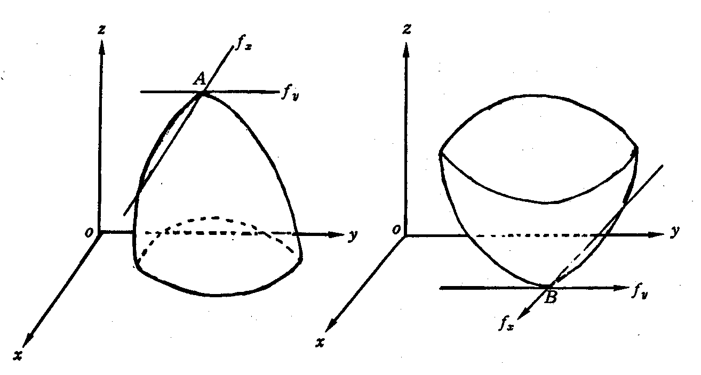
圖1 圖2
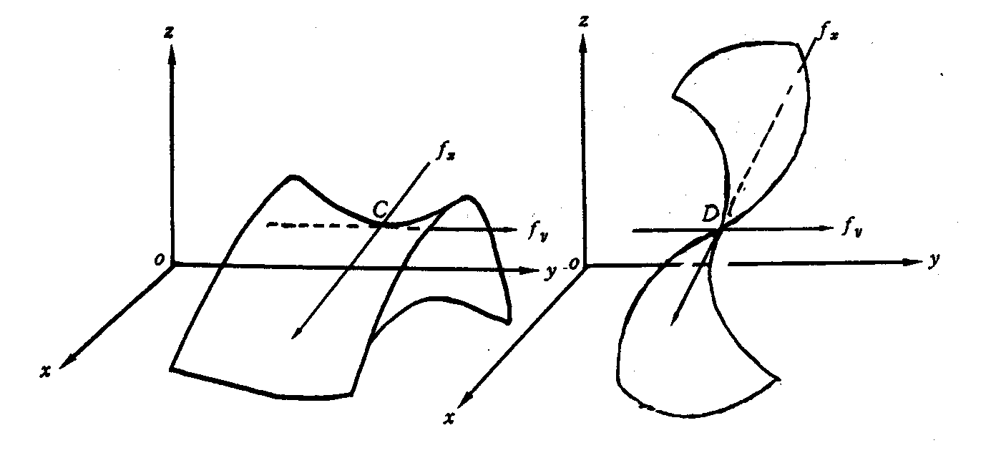
圖3 圖4
但由圖3、圖4可知第一次偏導數等於零，乃相對極值存在之必要但非充分條件。欲探討充分條件得進一步察看二次偏導數或二次全微分。
(2)二階條件： 相對極大之充分條件為d²z<0
相對極小之充分條件為d²z>0
圖1，A點若為相對極大則z_{A}點最高，dz_{A}=0，在xy平面上以（x₀,y₀
）為中心點，向任何方向變化所對應之函數值z均小於z_{A}，即dz_{A}
遞減，故d²z_{A}=d（dz_{A}）<0。
 圖2，B點若為相對極小則z_{B}點最低，dz_{B}=0，在xy平面上以（x₁,y₁
）為中心點，向任何方向變化所對應之函數值z均高於z_{B}，即dz_{B}
遞增，故d²z_{B}=d（dz_{B}）>0。
(3)
$d^{2}z=\text{fxx}{\left(\text{dx}\right)}^{2}+2\text{fxy}\left(\text{dx}\right)\left(\text{dy}\right)+\text{fyy}{\left(\text{dy}\right)}^{2}$……………..(5-83)
$$=\text{fxx}\left[{\left(\text{dx}\right)}^{2}+2\frac{\text{fxy}}{\text{fxx}}\left(\text{dx}\right)\left(\text{dy}\right)+\frac{\text{fyy}}{\text{fxx}}{\left(\text{dy}\right)}^{2}\right]$$
$=\text{fxx}\left\{\left[{\left(\text{dx}\right)}^{2}+2\frac{\text{fxy}}{\text{fxx}}\left(\text{dx}\right)\left(\text{dy}\right)+{\left(\frac{\text{fxy}}{\text{fxx}}\text{dy}\right)}^{2}\right]−{\left(\frac{\text{fxy}}{\text{fxx}}\text{dy}\right)}^{2}+\frac{\text{fyy}}{\text{fxx}}{\left(\text{dy}\right)}^{2}\right\}$…（5-84）
$$⇒d^{2}z=\text{fxx}{\left[\text{dx}+\frac{\text{fxy}}{\text{fxx}}\text{dy}\right]}^{2}+\frac{{\left(\text{dy}\right)}^{2}}{\text{fxx}}\left[\text{fxxfyy}−f^{2}\text{xy}\right]$$
若上式等式右邊各項均為正，即fxx>0與fxxfyy>f²xy則d²z必為正定，此為相對極小值之充分條件。
若上式等式右邊各項均為負，即fxx<0與fxxfyy>f²xy則d²z必為負定，此為相對極大值之充分條件。
⇒ a. 當fxx與fyy同號，才有相對極值。
b. 當fxx與fyy異號，則fxxfyy<0≦f²xy，此時式（5-84）等號右邊第二項之符號未定，因而d²Z之符號不能確定，即fxx>0與fyy<0或fxx<0與fyy>0，必為鞍點。
$\left|D_{2}\right|=\text{fxxfyy}−f^{2}\text{xy}=\begin{aligned}\left|\text{fxx} \text{fxy} | \right| \\ \end{aligned}$

$\left|D_{1}\right|=\left|\text{fxx}\right|=\text{fxx}$為$\left|D_{2}\right|$之子行列式
$\left|D_{1}\right|$與$\left|D_{2}\right|$是為相對極值存在之判別式，又稱之Hessian行列式。常以$\left|H_{1}\right|$與$\left|H_{2}\right|$取代$\left|D_{1}\right|$、$\left|D_{2}\right|$。
將$\left|D_{2}\right|$代入（5-83）式得：
$$d^{2}z=\left[\text{dx} \text{dy}\right] \begin{aligned}\left[\text{fxx} \text{fxy} | \right] \\ \end{aligned}$$
結論：
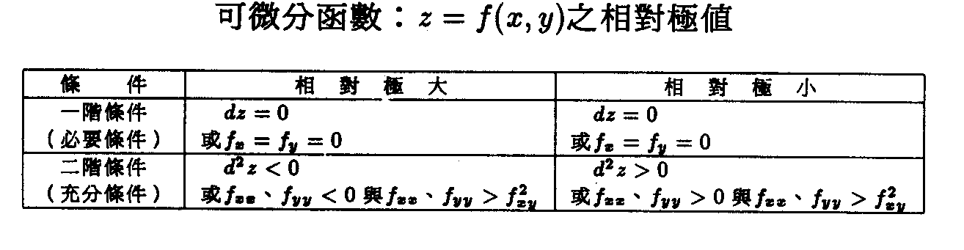
3.三個獨立變數可微分函數之極值
$w=f\left(x,y,z\right)$
$⇒\text{dw}=\text{fxdx}+\text{fydy}+\text{fzdz}$（=0，此必要條件）
$$\begin{aligned}d^{2}w=d\left(\text{dw}\right)=d\left(\text{fxdx}+\text{fydy}+\text{fzdz}\right) \\ =\text{fxx}{\left(\text{dx}\right)}^{2}+\text{fxy}\left(\text{dx}\right)\left(\text{dy}\right)+\text{fxz}\left(\text{dx}\right)\left(\text{dz}\right) \\ +\text{fyx}\left(\text{dy}\right)\left(\text{dx}\right)+\text{fyy}{\left(\text{dy}\right)}^{2}+\text{fyz}\left(\text{dy}\right)\left(\text{dz}\right) \\ +\text{fzx}\left(\text{dz}\right)\left(\text{dx}\right)+\text{fzy}\left(\text{dz}\right)\left(\text{dy}\right)+\text{fzz}{\left(\text{dz}\right)}^{2}\end{aligned}$$
$\begin{aligned}⇒d^{2}w=\text{fxx}{\left(\text{dx}\right)}^{2}+2\text{fxy}\left(\text{dx}\right)\left(\text{dy}\right)+2\text{fxz}\left(\text{dx}\right)\left(\text{dz}\right) \\ +\text{fyy}{\left(\text{dy}\right)}^{2}+2\text{fyz}\left(\text{dy}\right)\left(\text{dz}\right)+\text{fzz}{\left(\text{dz}\right)}^{2}\end{aligned}$…….（5-87）
令$\left|D_{3}\right|=\begin{aligned}\left|\text{fxx} \text{fxy} \text{fxz} | \right|\left|\text{fyx} \text{fyy} \text{fyz} | \right| \\ \end{aligned}$
$$d^{2}w=\left[\text{dx} \text{dy} \text{dz}\right]\begin{aligned}\left[\text{fxx} \text{fxy} \text{fxz} | \right]\left[\text{fyx} \text{fyy} \text{fyz} | \right] \\ \end{aligned}$$
經二次配方法將$\left|D_{1}\right|$、$\left|D_{2}\right|$、$\left|D_{3}\right|$代入後：
$$\begin{aligned}d^{2}w=\text{fxx}{\left[\text{dx}+\frac{\text{fxy}}{\text{fxx}}\text{dy}+\frac{\text{fxz}}{\text{fxx}}\text{dz}\right]}^{2}+\frac{\text{fxxfyy}−f^{2}\text{xy}}{\text{fxx}}{\left[\text{dy}+\frac{\text{fxxfyz}−\text{fxyfxz}}{\text{fxxfyy}−f^{2}\text{xy}}\text{dz}\right]}^{2} \\ +\frac{\text{fxxfyyfzz}−{\text{fxxf}}^{2}\text{yz}−{\text{fyyf}}^{2}\text{xx}−{\text{fzzf}}^{2}\text{xy}+2\text{fxyfxzfyz}}{\text{fxxfyy}−f^{2}\text{xy}}{\left(\text{dz}\right)}^{2}\end{aligned}$$
$⇒d^{2}w=\left|D_{1}\right|{\left[\text{dx}+\frac{\text{fxy}}{\text{fxx}}\text{dy}+\frac{\text{fxz}}{\text{fxx}}\text{dz}\right]}^{2}+\frac{\left|D_{2}\right|}{\left|D_{1}\right|}{\left[\text{dy}+\frac{\text{fxxfyz}−\text{fxyfxz}}{\text{fxxfyy}−f^{2}\text{xy}}\text{dz}\right]}^{2}+\frac{\left|D_{3}\right|}{\left|D_{2}\right|}{\left(\text{dz}\right)}^{2}$…..(5-89)
(1)若上式（5-89）右邊之平方項係數均為負，則$d^{2}w<0$；此為$w$有相對極大之充分條件即：$\left|D_{1}\right|<0$，$\left|D_{2}\right|>0$與$\left|D_{3}\right|<0$。
(2) 若上式（5-89）右邊之平項係數均為正，則$d^{2}w>0$；此為$w$有相對極小之充分條件即：$\left|D_{1}\right|>0$，$\left|D_{2}\right|>0$與$\left|D_{3}\right|>0$。

4.推廣至n個獨立變數可微分函數之極值：
$y=f\left(x_{1},x_{2},\text{.}\text{.}\text{.}\text{.},x_{n}\right)$
$⇒\text{dy}=f_{1}{\text{dx}}_{1}+f_{2}{\text{dx}}_{2}+\text{.}\text{.}\text{.}\text{.}\text{.}\text{.}\text{.}f_{n}{\text{dx}}_{n}$（=0，此為必要條件）
$$\begin{aligned}d^{2}y=\underset{\left(1×n\right)}{X'} \underset{\left(n×n\right)}{D} \underset{\left(n×1\right)}{X} \\ X'=\left[{\text{dx}}_{1},{\text{dx}}_{2},\text{.}\text{.}\text{.}\text{.}\text{.}{\text{dx}}_{n}\right]\end{aligned}$$
D表n階矩陣
$$\begin{aligned}\left|D_{1}\right|=\left|f_{\text{11}}\right|=f_{\text{11}} \\ \left|D_{2}\right|=\begin{aligned}\left|f_{\text{11} } f_{\text{12}} | \right| \\ \end{aligned} \\ \end{aligned}$$
透過二次配方法可得：
$$d^{2}y=\left|D_{1}\right|{\left(\right)}^{2}+\frac{\left|D_{2}\right|}{\left|D_{1}\right|}{\left(\right)}^{2}+\text{.}\text{.}\text{.}\text{.}\text{.}\text{.}+\frac{\left|D_{n}\right|}{\left|D_{n−1}\right|}{\left({\text{dx}}_{n}\right)}^{2}$$
為節省篇幅，以(•)²表示其平方項之元素
(1)${\left(−1\right)}^{i}\left|\text{Di}\right|>0$，則$d^{2}y<0$為相對極大之充分條件。
(2)$\left|\text{Di}\right|>0$，則$d^{2}y>0$為相對極小之充分條件。

5.總結：
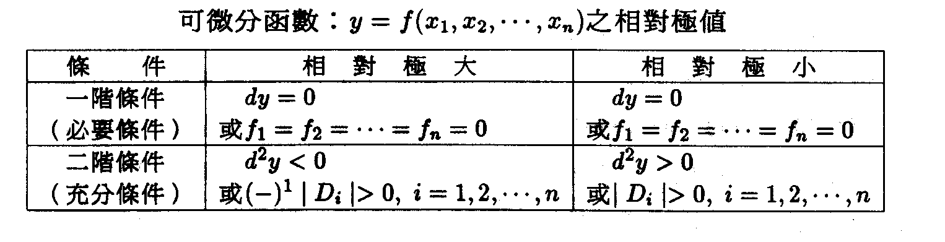

5.9實例
若 $\begin{aligned}\text{TR}=P_{1}Q_{1}+P_{2}Q_{2} \\ \text{TC}=2Q_{1^{2}}+Q_{1}Q_{2}+2Q_{2^{2}} \\ π\left(Q_{1},Q_{2}\right)=\text{TR}−\text{TC}=P_{1}Q_{1}+P_{2}Q_{2}−\left(2Q_{1^{2}}+Q_{1}Q_{2}+2Q_{2^{2}}\right)\end{aligned}$
廠商追求最大利潤，其一階之必要條件為：
(1) $\frac{∂π}{∂Q_{1}}=\frac{∂π}{∂Q_{2}}=0$
$\begin{aligned}\left\{\frac{∂π}{∂Q_{1}}=P_{1}−4Q_{1}−Q_{2}=0 | \right.\end{aligned}$
(2)$\left|H_{2}\right|=\begin{aligned}\left|\frac{∂^{2}π}{∂Q_{1^{2}}} \frac{∂^{2}π}{∂Q_{1}∂Q_{2}} | \right| \\ \end{aligned}$
$\left|H_{1}\right|=\left|−4\right|=−4<0$
符合極大值之二階條件，因此所求得之利潤必為最大。

5-10利用線性組合判別函數形狀
- 函數f(x)之形狀
呈嚴謹開口向$\begin{aligned}\left\{下 | \right.\end{aligned}$
綫段高度 弧高
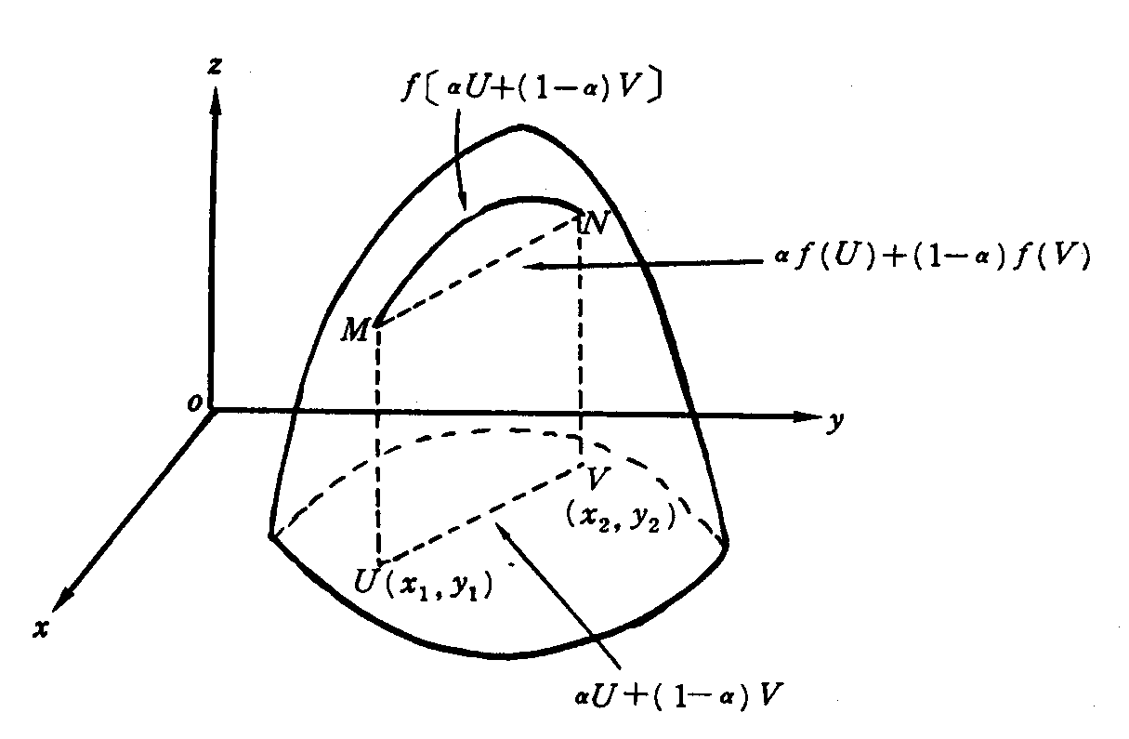
※在f(x)上任取不重合之兩點（U與V，見上圖）：
開口向上之函數⇐若兩點間聯線之綫段高度不小於所對應之弧高
開口向下之函數⇐若兩點間聯線之綫段高度不大於所對應之弧高
準開口向下函數(quasi-concave)⇐若弧高不低於綫兩端之最低點
嚴謹準開口向下函數(strictly quasi-concave)⇐若弧高高於綫兩端之最低點

- 注意：開口向下之函數一定是準開口向下之函數，但準開口向下之函數則不一定是開口向下之函數
- 由以上可得下列之定理：
  - 定理1：
若f(x)為一直綫型函數，則f(x)為一形狀開口向下之函數，而亦為一開口向上之函數，但均不屬嚴謹開口向上（下）之函數。
  - 定理2：
若f(x)為開口向下之函數，則-f(x)則為開口向上之函數，反之亦然。
若f(x)為嚴謹開口向下之函數，則-f(x)則為嚴謹開口向上之函數，反之亦然。

(3)定理3：
若f(x)與g(x)均為開口向下（上）之函數，則f(x)+g(x)必為開口向下（上）之函數
若f(x)與g(x)均為開口向下（上）之函數，且其中之一或兩者均為嚴謹開口向下（上）之函數，則f(x)+g(x)必為嚴謹開口向下（上）之函數

4.函數形狀與極值之判斷，見下圖。
求函數f(x₁,x₂,x₃,…,x_{n})之極值時，如事先知道函數形狀是開口向下或向上，則只要求其必要條件（一階導數均為零）即可，而不必再求其二階條件以檢定之。

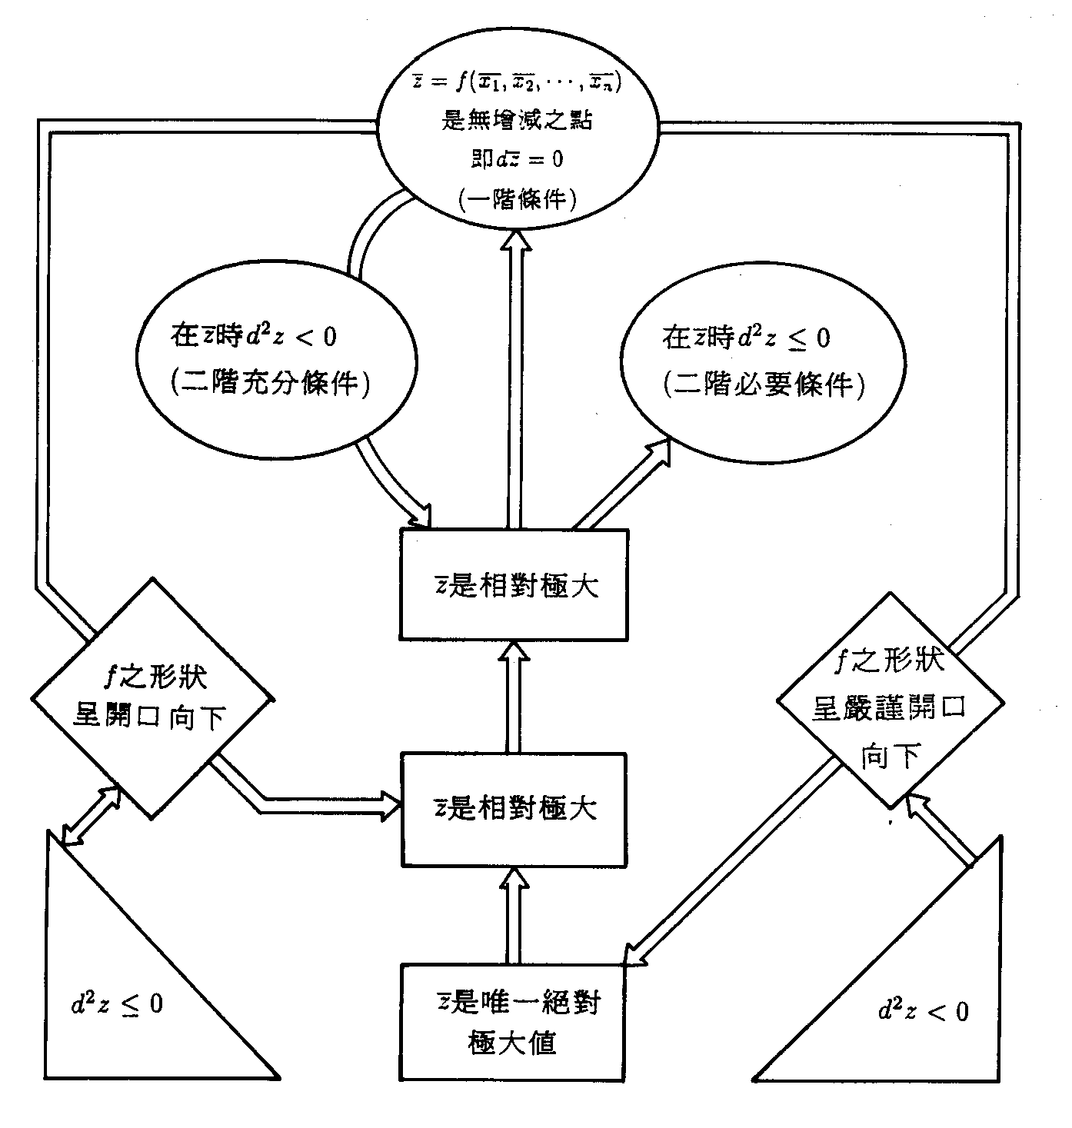

5.實例：判別函數$Z=2x^{2}−\text{xy}+y^{2}$之圖形
假設$U=(x_{1},y_{1})與V=(x_{2},y_{2})\text{為函數}Z\text{定義域內不重合之兩點}$
$$αf(U)+(1−α)f(V)=αf(x_{1},y_{1})+(1−α)f(x_{2},y_{2})$$
$=α(2x_{1}^{2}−x_{1}y_{1}+y_{1}^{2})+(1−α)[2x_{2}^{2}−x_{2}y_{2}+y_{2}^{2}]\text{.}\text{.}\text{.}\text{.}\text{.}\text{.}\text{.}(5−\text{121})$

$f[αU+(1−α)V]=f[α(x_{1},y_{1})+(1−α)(x_{2},y_{2})]$$=f[{αx}_{1}+(1−α)x_{2},{αy}_{1}+(1−α)y_{2}]$
$=2[{αx}_{1}+(1−α)x_{2}]^{2}−[{αx}_{1}+(1−α)x_{2}][{αy}_{1}+(1−α)y_{2}]+[{αy}_{1}+(1−α)y_{2}]^{2}$$=2[α^{2}x_{1}^{2}+2α(1−α)x_{1}x_{2}+(1−α)^{2}x_{2}^{2}]−α^{2}x_{1}y_{1}−α(1−α)x_{2}y_{1}−$
$α(1−α)x_{1}y_{2}−(1−α)^{2}x_{2}y_{2}+α^{2}y_{1}^{2}+2α(1−α)y_{1}y_{2}+(1−α)^{2}y_{2}^{2}\text{.}\text{.}\text{.}(5−\text{122})$
將式(5-121)減去式(5-122)得：
$$αf(U)+(1−α)f(V)−f[αU+(1−α)V]$$
$$=α(1−α)[2x_{1}^{2}−x_{1}y_{1}+y_{1}^{2}+2x_{2}^{2}−x_{2}y_{2}+y_{2}^{2}−4x_{1}x_{2}+x_{2}y_{1}+x_{1}y_{2}−2y_{1}y_{2}]$$
$$=α(1−α)[2(x_{1}−x_{2})^{2}+(y_{1}−y_{2})^{2}−(x_{1}−x_{2})(y_{1}−y_{2})]$$
$$=2α(1−α)\left\{[(x_{1}−x_{2})−\frac{1}{4}(y_{1}−y_{2})]^{2}+\frac{7}{\text{16}}(y_{1}−y_{2})^{2}\right\}>0$$

⇒綫段高度>弧高，故函數Z為嚴謹開口向上之形狀。

